2023 RACIAL EQUITY COMMUNITY FUND

REQUEST FOR PROPOSALS

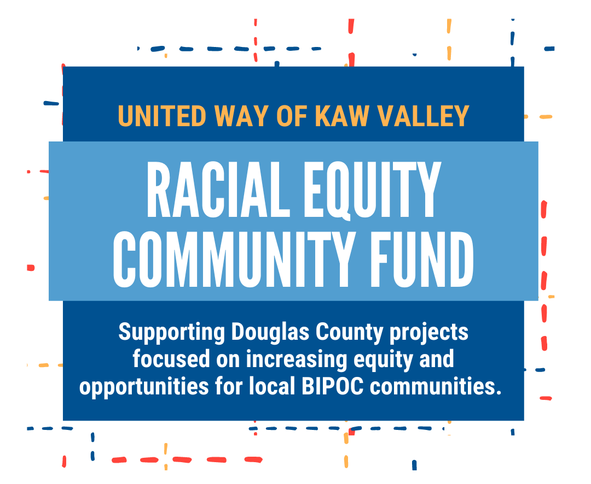

Application Due:
Friday, March 10, 2023, by 5:00pm CST

For more information:
Kathy Smith
VP Douglas County Initiatives
ksmith@uwkawvalley.org
785-581-0232 ext.1001

INTRODUCTION
The United Way envisions a just, equitable and inclusive community for residents of all racial and ethnic backgrounds. The United Way of Kaw Valley acknowledges that the fight against poverty must be inclusive and anti-racist. The focus of this grant is to support projects that build community, leadership, and direct supports for all marginalized community groups.

ELIGIBILITY CRITERIA
Funds will be invested in grassroots and/or community nonprofit organizations in Douglas County, KS with projects focused on increasing equity and opportunities for local BIPOC communities. These grants provide support for organizations or individuals whose work benefits people with low incomes, communities of color, and historically and/or systematically marginalized people. Collaborative efforts and coalitions are eligible to apply.
Priority will be given to organizations who are:
- led by Black, Indigenous, People of Color with organizational mission and goals focused on elevating and increasing equity for their communities.
- leading efforts that include power-building with and for BIPOC communities.
- taking a multi-generational approach that prioritizes youth and families.
- aligning with United Way’s mission of ending poverty, facilitated by equitable access to quality education, healthcare, jobs, housing, food, and community engagement.
- embedding trauma-informed practices into their work by acknowledging the widespread impact of trauma.

Not eligible for funding:
- Organizations with budgets over $500,000
- Organizations with less than 25% BIPOC executive leaders and board members
- Government programs
- Other foundations or granting programs
- Public, private, or charter schools
- College or university programs
- Businesses or business associations
- Organizations outside of the Douglas County, KS service area

FUNDING
Grant awards will be $5,000.00 or less. Applications are due Friday, March 10 by 5:00pm CST.

PRIORITY POPULATION
Priority population for these funds are Black, Indigenous, People of Color living in Douglas County, KS, with a minimum of 75% of people served identifying as Black/African American, Indigenous/Native, Asian Pacific Islander, Chican@/Latinx, Middle Eastern, and/or People of Color.

Priority will be given to projects that focus on the intersections of BIPOC identities, bringing those systemically pushed to the margins to the center of the project. These intersections may include:
- Socioeconomic status
- Sexual orientation
- Gender identity
- Age
- Ability
- Immigration status
The highest priority will be given to projects focused on the intersections of racism and poverty.
The following activities are not eligible for funding:
- Direct service/safety net supports that are contingent on agreement to case management, education, continued program participation, or citizenship status.
- Individuals may not apply for the grant for their own benefit
- Research expenses
- Capital or endowment campaigns.

ELIGIBLE ACTIVITIES
The eligible activity categories for funding are Direct Supports, Advocacy, and Community Building.

 | Direct Supports | Advocacy | Community Building
What it is | Activities that support and/or serve an individual, family, or group with a direct service need | Activities that aim to influence decisions within political, economic, and social institutions | Activities directed toward the creation or enhancement of community, serving to develop community assets, social capital, and decrease isolation
Examples of funded activities  (not an exclusive list) | Meal preparation and/or delivery  Early liberation literacy programs (book drives & tutoring that highlight BIPOC strengths and culture)  Basic needs supplies to individuals and families  Attorney and expungement fees | Education that will inform and activate residents on policy advocacy and community organizing  Racial equity and justice education to counteract the impact of white supremacy  Activities to “till the soil” for advocacy, including root cause and power analysis, and campaign development  Advocacy coalition building  Direct action | Mobilizing residents to take action on community-level change  Leadership programs that identify, develop, and mobilize new community leaders for racial justice  Activities that foster inclusive communities of belonging (e.g. public art, block parties and BBQs, neighborhood “walk-up” movie nights, community concerts featuring BIPOC artists)

REVIEW PROCESS

HOW TO APPLY
Applications are due no later than Friday, March 10 at 5:00pm CST. If you are unfamiliar with grant writing, please feel free to make an appointment with Kathy Smith or stop by the office during our Racial Equity grant office hours listed on the Application.

A full application is available online through the United Way of Kaw Valley website www.uwkawvalley.org. Paper copy applications are also available in our office at 1127 Iowa from 9:00am-5:00pm Monday- Thursday, and 9:00-1:00 Friday.

FUNDING DECISIONS
All completed applications will be reviewed and funding recommendations made by a carefully selected panel of Douglas County residents. Funding decisions will be communicated before April 5, 2023.

PROPOSAL SCORING
Our goal is to fund the programs that will best serve those most impacted by poverty and discrimination. Applications will be scored using a standardized rubric so that all applicants are evaluated on the same criteria.

The following criteria are used when reviewing proposals.

- Is the application thorough and complete?
- Does the applicant have the capacity to carry out proposed activities?
- Is the project activity aligned with the fund goal?
- Do the proposed activities align to achieve the goal?
- Is the project well thought-out with adequate planning?
- Does the project have a plan to meaningfully measure and report success?
- Is the budget complete, accurate & clear?
- Does the organization have majority BIPOC leadership?

For more information:
Kathy Smith, VP Douglas County Initiatives
ksmith@uwkawvalley.org (785) 581-0232 ext.1001

APPLICATION

Applications are due in the office by Friday, March 10, 2023 by 5:00pm CST. You may email a Word document or PDF or submit a paper copy in person/by mail. Late applications cannot be accepted for consideration.

**You are welcome to fill in this application, or to use it as a guide to apply using your own paper.

- Organization name Click or tap here to enter text.

- Primary contact ____________________________________________________

- Email Address(es) ____________________________________________________

- Mailing address: Street ________________________________________________
City __________________ Zip ___________

- Location of activities if different than Mailing Address:
Click or tap here to enter text.

- Website: ______________________________________

- Phone number: ______________________________
- Is your organization designated as a 501c3 nonprofit? ☐ Yes ☐ No
  - If yes, what is your EIN number? ___________________________
  - If no, is there a nonprofit organization partner (such as a church) involved with your program or project? If so, who? _______________________________________________

- Project Name ____________________________________________

- Project summary – please provide a summary for the project or program (max 100 words):
Click or tap here to enter text.

- Tell us about your organization and the work you do.

What is the history of your organization?
Click or tap here to enter text.

Describe the mission and values of the work you do:
Click or tap here to enter text.

Do you have collaborators or partners who work with your organization and/or this project? If so, please describe.
Click or tap here to enter text.

What experience does your organization have in designing and implementing community projects for racial equity?
Click or tap here to enter text.

- Please provide a simple project timeline noting major activities.
Click or tap here to enter text.

- What are your project goals?

Click or tap here to enter text.

- How will your project and goals create more equitable opportunities for BIPOC communities?

Click or tap here to enter text.

- Describe the community being reached with this project:
Click or tap here to enter text.

- Approximately how many people do you anticipate reaching? Where applicable, indicate the number of children (infant-18years), adults (over18+ years). Are you primarily serving children? Adults? Families?

Click or tap here to enter text.

- Amount of request (max $5,000.00) Click or tap here to enter text.

- Project budget (see attached form)

Attachments:
- Contact list of all paid and unpaid group leaders, including contact information
- Optional: Any materials you wish to submit to showcase past work (flyers, training manuals, reports, etc.)

Application timeline:
- Friday, March 3, 1:00-4:00: Application assistance office hours at 1127 Iowa
- Tuesday, March 7, 4:00-6:00pm: Application assistance office hours at 1127 Iowa
- Friday, March 10, 5:00pm CST: Applications are due in the United Way of Kaw Valley office at 1127 Iowa whether by email, mail or dropped off in person.
- Friday, March 31 Funding announcements will be made by this date
BUDGET FORM
Please include projected expenses, anticipated income (including in-kind), and the total project budget. Provide descriptions for all entries. Please make sure that expenses and income balance.

Project Title: Total Budget Amount:
EXPENSES (modify categories to fit your project)
Fees (people costs, like staff or vendors)
Category | Amount | Notes
Subtotal fees | $
Production (supplies, like food, space rental, or tools)
Subtotal production | $
Marketing (supplies for outreach and advertising)
Subtotal marketing | $
TOTAL EXPENSES | $0.00

INCOME (donations, merch/ticket sales, etc. Modify categories to fit your project)
Racial Equity Grant (requested amount)
Subtotal Income | $
IN-KIND DONATIONS (gifted services or items. Should match items described in the EXPENSES section above)
Subtotal In-kind | $
TOTAL INCOME + TOTAL IN-KIND | $0.00 | This sum should equal expenses on previous page
Please use the space below to clarify any unusual circumstances connected to your budget for this project:

